Lab Report 1: Correlation between Number of Years at School and Number of Friends at School
Sveta Mnatsakanyan
Glendale Community College
PSYCH 200 LAB: Research Methods
May 31/2021

Introduction
Two variables can be studied how they related to each other. The correlation between two study variables can be positive, in which case an increase in one variable increases the other. However, if one variable decrease as the other increase, the correlation is negative (Akoglu, 2018).
Study Purpose
The study aimed at establishing the correlation between the number of years at school and the number of friends one makes at school.
Hypothesis
- The number of years at school is positively related to the number of friends one makes at school.
- The number of years at school is negatively related to the number of friends one makes at school.
Methods
The participants were randomly selected, and each one asked how many friends they have made in school based on the number of years they have stayed in school. The number of years will be the independent variable while the number of friends will be the dependent variable, then the results used to plot a line of best fit in excel.
Results
The graph below indicates that the number of years at school is positively related to the number of friends one makes at school. This is shown by the positively sloping graph, which indicates that as one spends more years at school, the more friends they are likely to make.
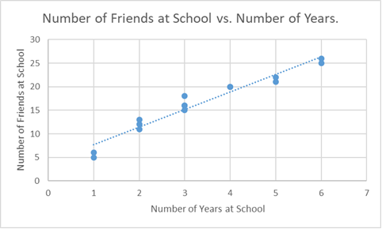
Figure 1: The relationship between the number of years spent at school and the number of friends
Conclusion
It is clear that by spending more time in school, they are likely to make more friends. Therefore, the number of friends is positively related to the number of years at school. However, an error might be made based on the assumption that they will make more friends as they spend more time in school. Nevertheless, the findings support the hypothesis that the number of years at school is positively related to the number of friends. It is also important to conduct a study that considers how the two variables influence each other.

References
Akoglu, H. (2018). User's guide to correlation coefficients. Turkish journal of emergency medicine, 18(3), 91-93.

